REGEX PROBLEM

THIS REGEX SEEMED TO HAVE MADE SEARCHES CASE INSENSITIVE IN THE COMMAND WINDOW BUT HAVING PROBLEM IMPLEMENTING IN CODE:

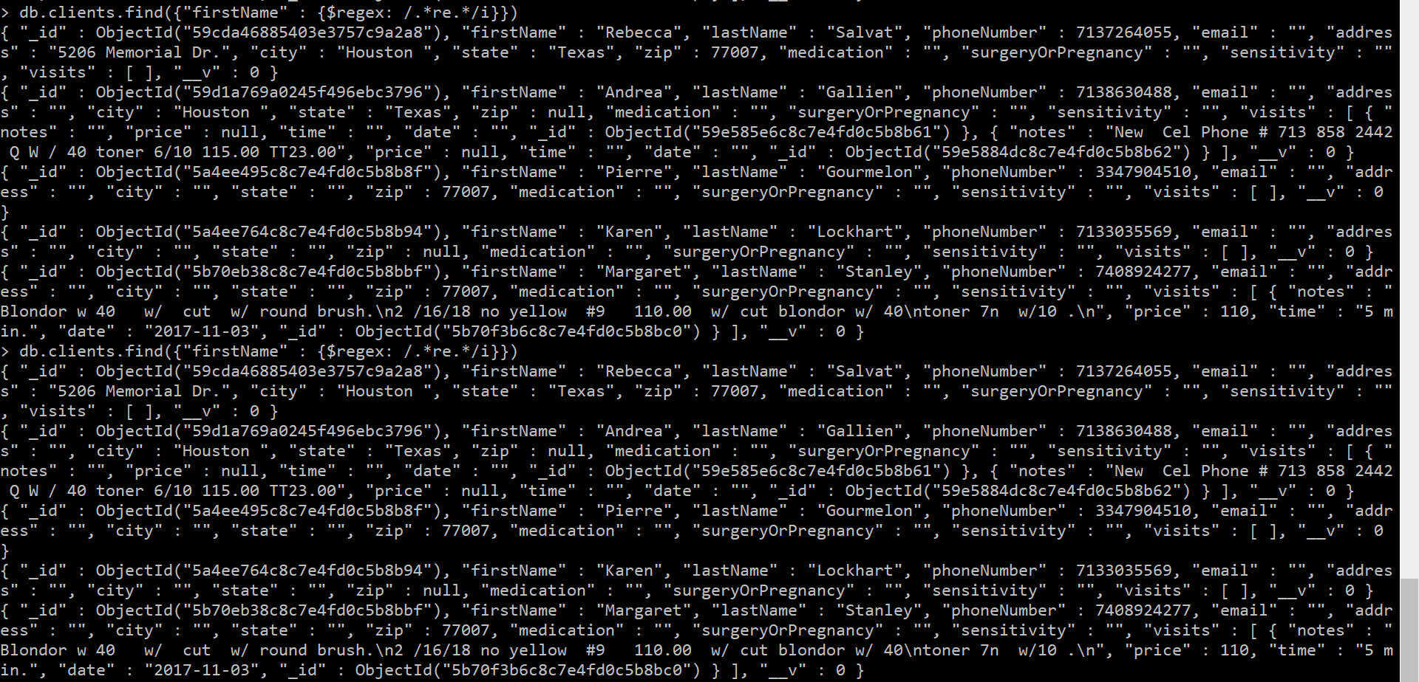

TRIED THIS BUT COULDN’T GET IT TO WORK:

